**Combinations**

n

k

( )= n!/[k!(n-k)!]

**cdf Cumulative Dist Function**

p(z)=P(X=z)

=P(X≤z)-P[X≤(z-1)]

=F(z)-F(z-1)

P(w≤X≤z)=F(z)-[F(w-1)]

P(w<X≤z)=F(z)-F(w)

P(w<X<z)=F(z-1)-F(w)

P(X>z)=1-F(z)

P(X≤z)=F(z)

P(X≥z)=1-P([X≤(z-1)]

P(a≤X≤b)=F(b)-F(a-) where a-

represents the largest possible

X value strictly less than a

**μ Expected Value/mean value**

E(x)=∑x▪p(x)

E[f(x)=E[f(x)]▪p(x)

E(ax+b)=a▪E(x)+b

Eg f(x)=x3+9x2+14x+5

E[f(x)]=E(x3)+9E(x2)+14E(x)+5

**σ2 Variance**

V(x)=∑(x-μ)2▪p(x)

V(x)=E(x2)-[E(x)]2

**σ Standard Deviation**

σ=√(V(x))

**Binomial probability dist**

n

x

b(x;n,p)=( )px(1-p)n-x

B(x;n,p)

USE CDF RULES

Use Table A.1 to find B(x;n,p)

z

B(x;n,p)=P(X≤z)= ∑ b(y;n,p)

y=0

b(x;n,p)= B(x;n,p)- B[(x-1);n,p]

For binomial prob dist

E(X)=mean value=μ=np

V(X)=np(1-p)🡪let (1-p)=q

σ=√[npq]

|  |  |  |  |  |  |  |  |
| --- | --- | --- | --- | --- | --- | --- | --- |
| %ile | 90 | 95 | 97.5 | 99 | 99.5 | 99.9 | 99.95 |
| α | .1 | .05 | .025 | .01 | .005 | .001 | .0005 |
| zα | 1.28 | 1.96 | 1.96 | 2.58 | 2.58 | 3.08 | 3.27 |

**Poisson probability dist**

Pmf= P(x;μ)=e-μ▪μx

x!

z

P(X≤z)=∑ e-μ▪μx

x=0

x!

note e-μ/0=1

eg for μ=4.5

P(X=5)=e-4.5▪4.55

5

5!

P(X≤5)=∑ e-4.5▪4.5x

x=0

x!

=e-4.5[1+4.5+(4.5)2/2!

+(4.5)3/3!+(4.5)4/4!+(4.5)5/5!]

=.7029

As n🡪∞ and p🡪0 and np=μ>0

Then b(x;n,p) 🡪p(x;μ)

Use when n>50 and np<5

Use Table A.1 to find F(x;n,p) AND

FOLLOW CDF RULES!!

For Poisson E(X)=μ=V(X)

**Continuous rv**

**pdf Probabilty Dist/Prob Dist Func**

X is a cont rv and a func of fx and a

and b are numbers in X s.t a≤x≤b

pdf🡪P(a≤X≤b)=∫ba f(x)dx

uniform🡪 f(x;A,B)=1/(B-A) for A≤X≤B

**cdf for Cont rv**

F(x)=P(X≤z)=∫z∞ f(y)dy

P(X≤/<z)=F(z)

P(X>/≥a)=1-F(a)

P(a≥X≥b)=F(b)-F(a) [IF RESULTS

ARE NEG, THEN F(a)-F(b)

**Percentiles of a cdf for cont rv**

F(η(p))🡪p=∫η(p)-∞ f(y)dy where η(p) is

the (100p)th percentile

**median** of a cont dist ῦ is F(ῦ)=.5

**Expected/mean value for cont rv**

μ=E(X)=∫∞-∞ x ▪ f(x)dx

**Variance for cont rv**

σ2=V(X)=E(X2)-[E(X)]2

**SD**=σ=√V(X)

**Normal Dist**

Has normal distribution where

-∞<μ<∞ and 0<σ if the pdf

f(x;μ,σ)=[e-(x-μ)²/(2σ²)]/[σ√(2π)]

**Standard normal random var**

F(z;0,1)= [e-z²/2]/[√(2π)]

P(Z≤x)=Φ(x)

P(w≤Z≤x)=Φ(x)-Φ(w

**Percentile from normal dist**

Use table 8.3 to find# closest to %.If ½way in

Between 2 #’s,use result ½way between

**Notation**

z denotes area under curve left of z axis

zα denotes area under curve right of z axis

Φ(zα)=1-α

**Nonstandard Normal Dist**

If X has normal dist with mean μ & SD σ, then

Z=(X-μ)/σ

has a standard norma dist. So

P(a≤X≤b)=P[(a-μ)/σ≤Z≤(b-μ)/σ]

=Φ[(b-μ)/σ] - Φ[(a-μ)/σ]

P(X≤a)=Φ[(a-μ)/σ]

P(X≥b)=1- Φ[(b-μ)/σ]

z value is the number of SD from the mean

**Percentiles of Arbitrary Norm Dist**

(100p)th percentile for norm (μ,σ)=

μ + [(100p)th for std norm]▪σ

**Approximating Binomial Dist**

P(X≤x)=B(x;n,p)

≈area under curve left of x+.5

=Φ[(x+.5−np)/(√np(1-p)]

Where np≥10 & n(1-p)≥10

**Distribution of the Sample Mean**

Let X1,X2…Xn be a random sample from a dist with

mean **μ** and standard deviation **σ**, then

**E(X) = μX = μ**

**V(X) = σ2/n AND σX = σ/√n [n>30;big n is good]**

T0=X1+…+Xn, E(T0)=nμ, V(T0)=nσ2, σT=σ√n

P(w≤X≤y)=P[(w-μ)/σ ≤ Z ≤ (y-μ)/σ]

=Φ[(**y**-μ)/σ] – Φ[(**w**-μ)/σ]

**Distribution of Linear Combination**

Let X1…Xn have mean values μ1…μn and var σ21…σ2n

1. Regardless whether X1…Xn are dependent or ind

E(a1X1+…+anXn)=a1E(X1)+…+anE(Xn)=a1μ1+…+anμn

2.If X1…Xn are independent,

V(a1X1+…+anXn)=a21V(X1)+…+a2nV(Xn)

=a21σ21+…+a2nσ2n

E(X1-X2) = E(X1) – E(X2) for 2 rv’s X1 and X2

V(X1-X2) = V(X1) + V(X2) if X1 and X2 are indep.

σX1-X2=√[V(X1-X2)]

**Point Estimation**

Ô = O + error of estimation

Unbiased Estimator E(Ô)=O

E(Ô) – O is called the bias of O

p = X/n is an unbiased estimator of p

Let X1...X2 be a random sample from a dist. With

mean μ and variance σ2, then the estimator,

σ2=S2=[Σ(Xi–X)2]/(n-1) is unbiased for σ2

μ=x=(Σxi)/n ; s=√(s2)=√[Σx2i – (Σxi/n)]/(n-1)

**Maximum Likelihood Estimator**

Suppose X1, X2,…,Xn is a random sample from an

exponential dist

f(x1,…,xn;λ) = (λe-λx1) ▪…▪(λe-λxn)=λne-λΣxi

so ln[f(x1,…,xn;λ)]= n lnλ - λΣxi

setting (∂/∂λ) ln[f(x1,…,xn;λ)]=0 🡪

n/λ-Σxi=0🡪λ=n/ Σxi = 1/x

**Properties of Confidence Intervals**

Using 95% confidence b/w -1.96 and 1.96

🡪

which are the left and right endpoints (limits) with in the middle or

**Levels of Confidence**

A 100(1-α) confidence interval for the mean μ of a normal population when σ is known is

|  |  |  |  |
| --- | --- | --- | --- |
| % | .90 | .95 | .99 |
| α | .1 | .05 | .01 |
| zα | 1.28 | 1.645 | 2.33 |
| zα/2 | 1.645 | 1.96 | 2.58 |
| width | 3.29 | 3.92 | 5.16 |

**Interval Width**

The sample size necessary for the CI to have a

width w (between is

The t critical value tα,v is the# on the axis for the area under the tv curve α to the right of tα,v

**Large Sample Interval**

If n is sufficiently large (n>40), then

so and

When trying to determine s from a range (eg between 300 and 500) divide the range by 4 (eg [500-300]/4=25 = s]

**CI for Population Proportion**

Let where =X/n sample of success

then a CI for a population proportion(score interval)

Where

If the sample size is very large then the score

interval is

**Interval width**

n

or n

**Large upper/lower confidence bound for μ**

Upper Bound Lower Bound

**T Distribution**

When is the mean of a random sample size n

from a normal dist with mean μ, the rv

has a probability dist called a

t distribution with n-1 dist. freedom (df)

**Properties of t distributions**

Let tv denote the t dist with df v

1.Each tv curve is bell shaped, centered at 0

2.Each tv curve is more spread out than a

normal (z) curve

3. As v↑, the spread of the tv curve↓

4. As v→∞ the sequence of tv curves

approaches the normal curve

**t critical value**

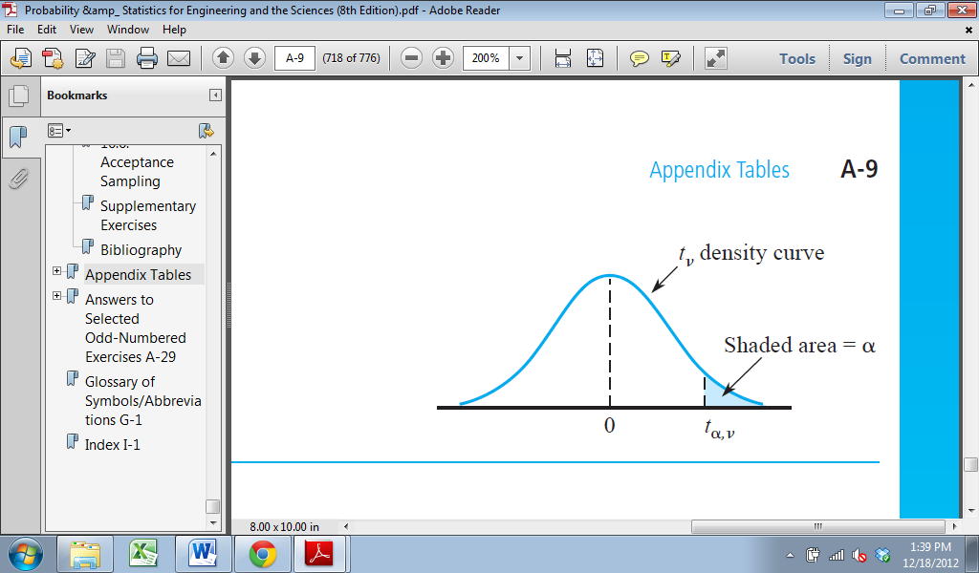

**One sample t confidence intervals**

Upper conf bound is +, lower conf bound is -

**Errors in Hypothesis Testing**

α→P(Type I error) – rejecting Ho when it is true

β→P(Type II error) – not rejecting Ho when it is false

**Case 1: a normal population with known σ**

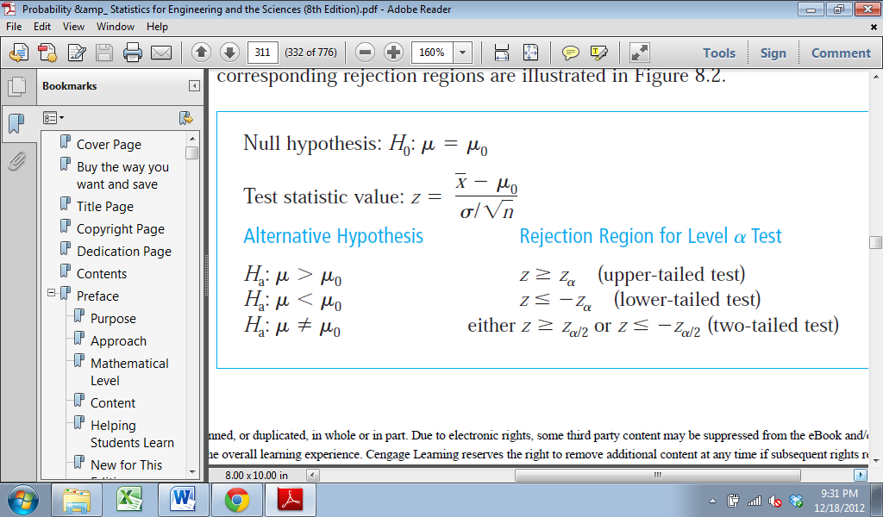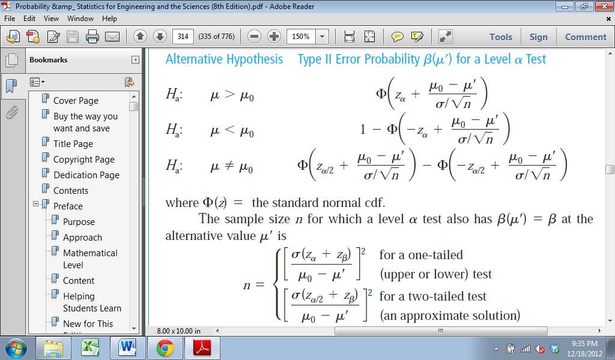

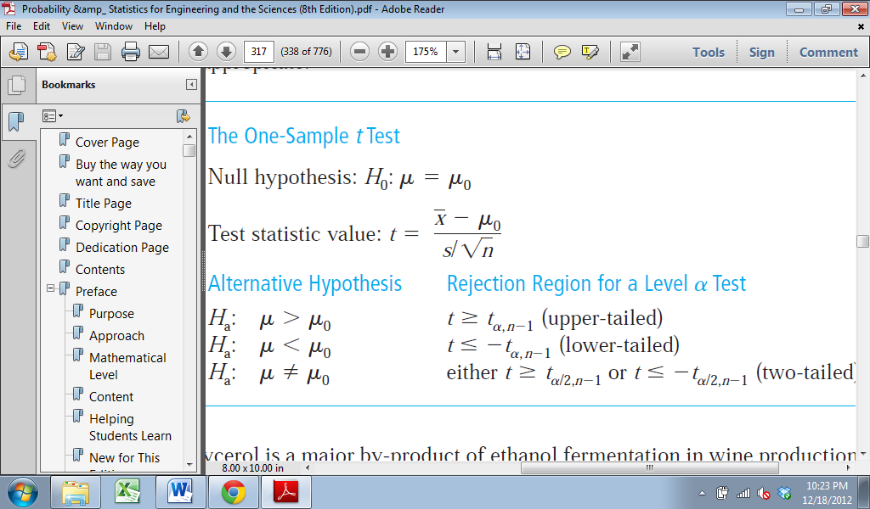

**Large sample Tests**

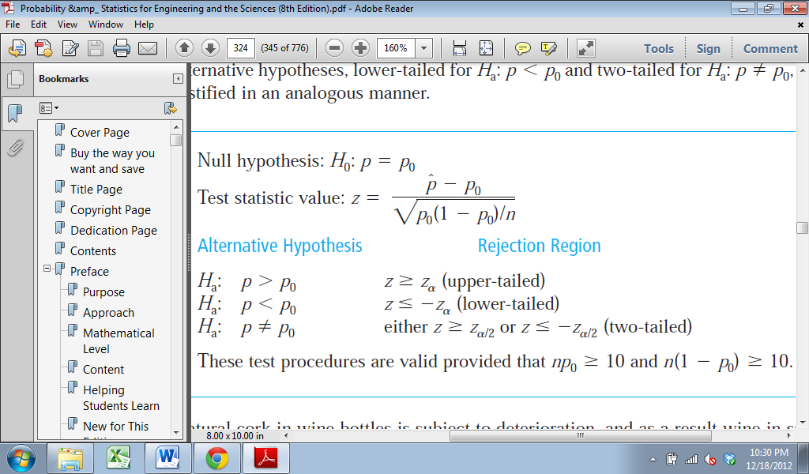

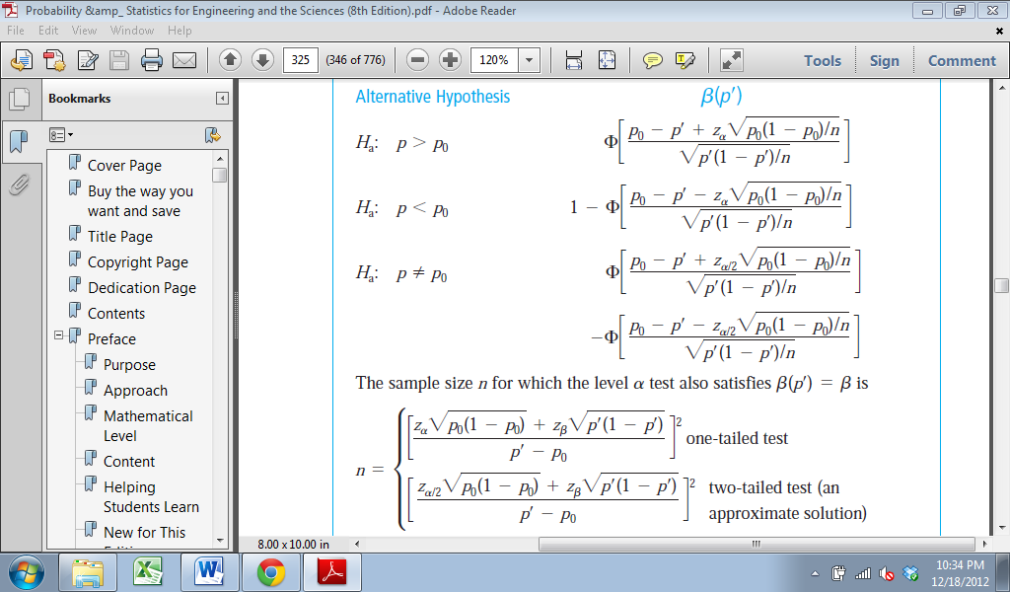

**P-Value**

